PAGE 1:
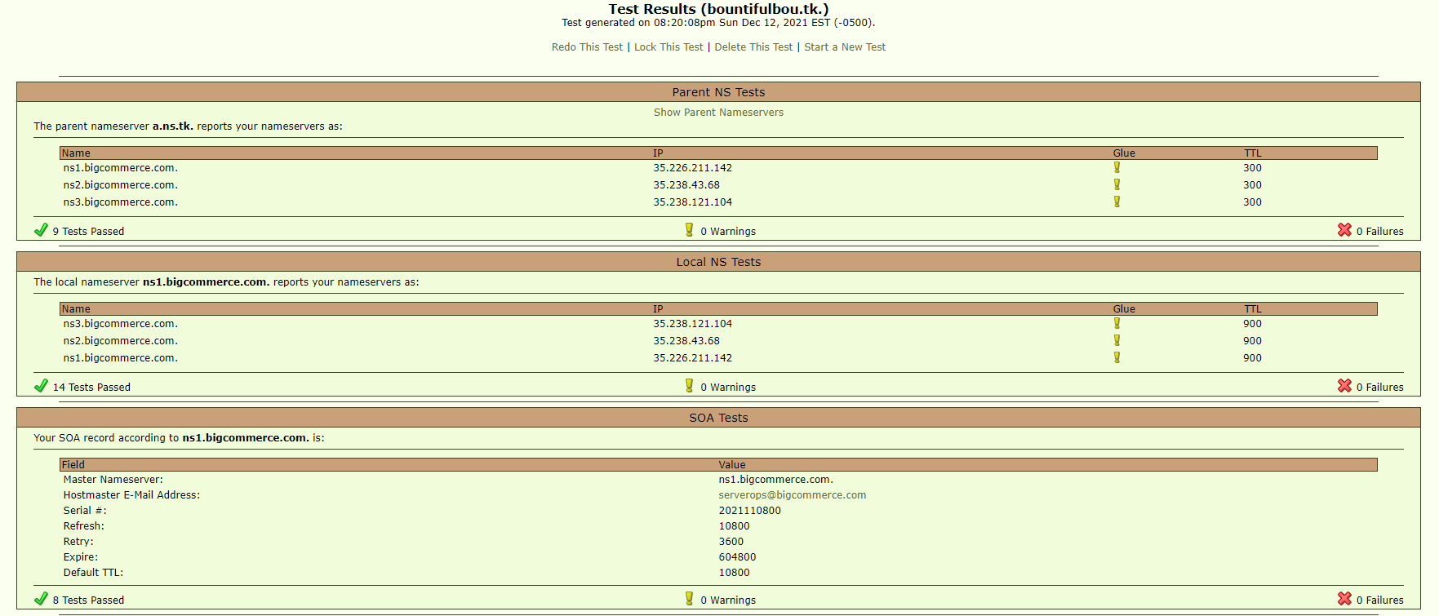

PAGE 2:
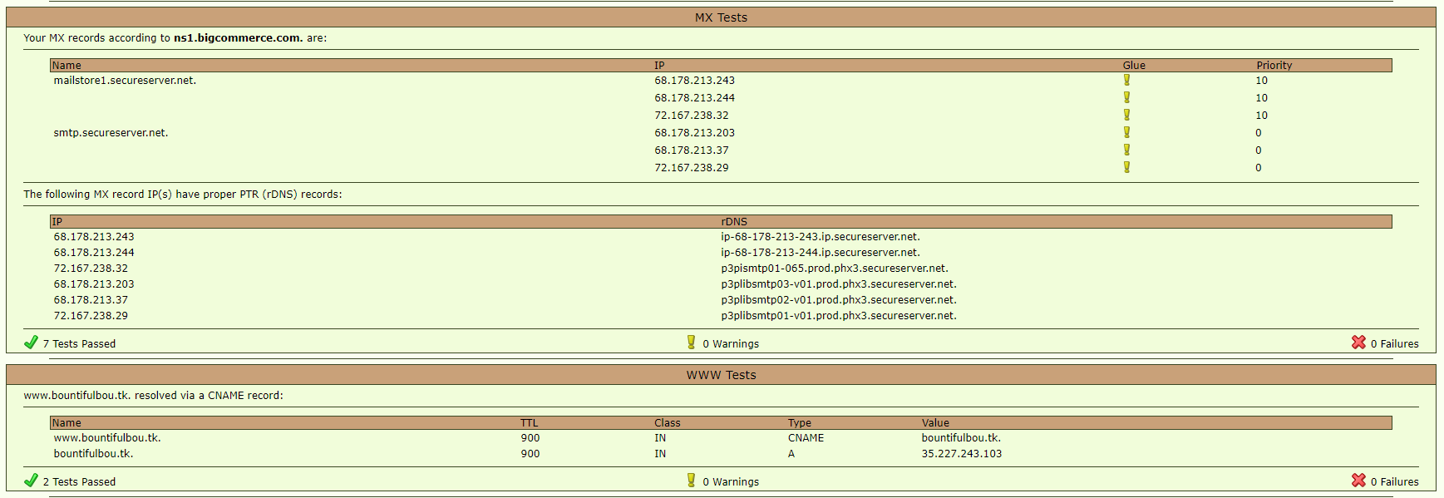

When looking at leafdns.com reports, there are two main things you’re looking for: the nameservers and the WWW tests.

Nameservers show up at the top of Page 1, right where the results start. The heading says “Parent NS Tests”

leafdns shows you the place where the site is registered followed by the nameservers listed there. If these are not BigCommerce nameservers, then a large percentage of what we could normally do for a merchant is out the window. Advise the merchant that they should probably point their nameservers our way, but it isn’t the only way.

WWW tests show up at the bottom of Page 2, and the heading says as much.

Leafdns shows that attempting to visit www.[domain].[suffix] follows some path using CNAME and A records. If the store is set up the way we normally default it, this should have a CNAME record resolving from www.[domain].[suffix] to [domain].[suffix], then an A record resolving from [domain].[suffix] to the IP address.

—

Outside of nameservers and WWW tests, Local NS Tests and SOA tests can be useful to confirm DNS settings are correctly configured.

Local NS Tests will show you at one of the nameservers listed what all the nameservers for the site are. If the store is pointed correctly to our nameservers, that should show up here as well.

SOA means “Start of Authority”, and it tracks the important rules associated with accessing the site as well as the last time the domain updated. In general, this shouldn’t be an issue, but it can occasionally clue you in to some settings being askew.

—

Finally, the MX records just indicate how the site is handling e-mail. RARELY this will cause problems with connection.

